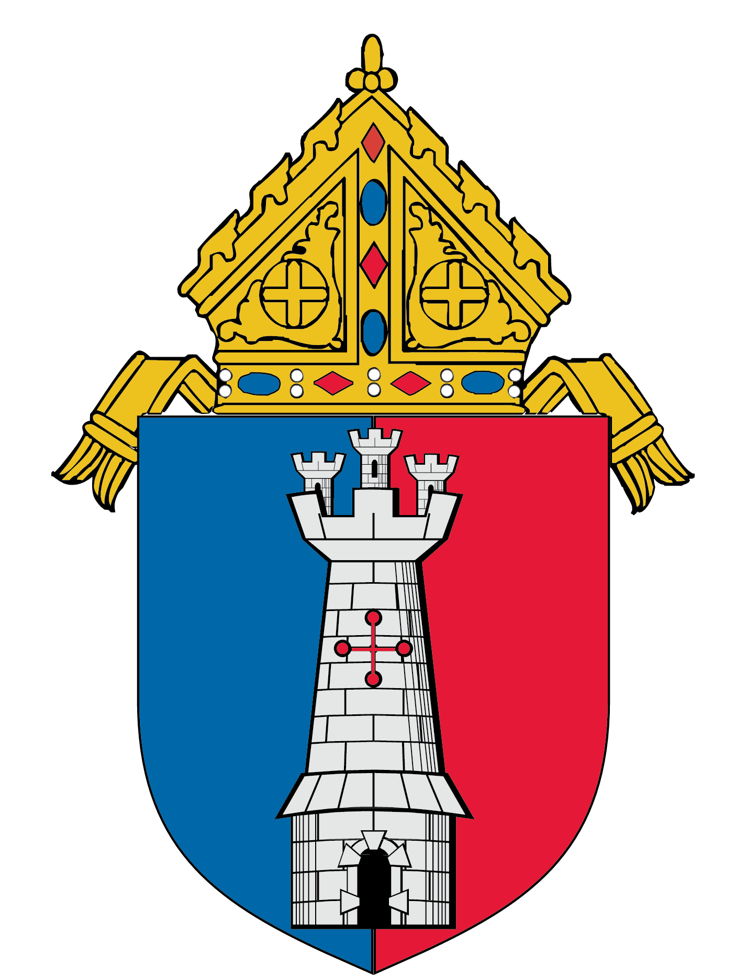

Youth Group and Campus Ministry Ideas:
Diocese of Toledo Videos for
National Vocation Awareness Week

When: National Vocation Awareness Week is the first full week of November. However, the videos and these lesson plan ideas can be used at any point during the year.

Message: God has a plan for our lives. There are practical ways for us to discover this plan.

Learning Objectives:
Raise awareness of the need to discern one’s vocation.
Help students understand how to hear God’s voice.
Inspire students to seek God’s plan for their lives.

The two videos (6 minutes each) are available online:
Fears: https://youtu.be/nL-QFVVbQJE
Hearing God’s Voice: https://youtu.be/BqxywqlhQjc
Google Drive link for both videos:
https://drive.google.com/drive/folders/1ZGTHCsYG4HvhQm3FZWHJkezCIxa5XPyr?usp=sharing

After watching the first video on fears about the future, students could be asked to respond to the following questions in a small-group discussion.

Facing Your Fears

What are the biggest decisions you are facing right now? Which decisions in your life are causing you the most stress and anxiety?

When have you experienced the following fears?

-fear of the unknown

-fear of disappointing others

-fear of missing out (FOMO)

-fear of making the wrong decision

-fear of failure

Give an example of someone who does not allow fear to get in the way of making good decisions? How can you learn from this person’s example?

The following passages could be used to help students understand a Biblical perspective on fear about decisions. One or more of these passages could be provided to the students for their reflection during a time of prayer, perhaps during Eucharistic Adoration.

God’s Advice on Facing our Fears:

Matthew 6:25-34

Matthew 28:1-10

Luke 1:26-38

Luke 5:1-11

Psalm 23

Psalm 139

1 Peter 5:6-11

Jeremiah 1:4-8

Jeremiah 29:11-13

After watching the video on hearing God’s voice, students could be asked to respond to the following questions in a small-group discussion.

Hearing God’s Voice

The Bible

What verses from the Bible have been most influential in your life?

When have the readings and homily at Mass spoken to your situation and helped you figure out more of God’s plan for your life?

Is there a figure from the Bible whose life is similar to yours? What do you have in common with this person? What can you learn from this person’s life?

Listen to your gut

Has there been a time in your life when you knew in your gut the right choice to make? Did you follow your conscience or did you ignore this voice? How did things turn out?

Use your head

As you consider a decision you have to make, what are the pros and cons of your options? Write them out. Does this help clarify what God might be asking of you?

Imagine you are at the end of your life and looking back on where you are right now. What recent choices would you regret? What recent choices would you be glad that you made?

The Church

Who in your life can you go to for advice about decisions that are causing your stress?

When in your life did a conversation with someone else help you with a difficult decision?

Resources:
For more material about Christian discernment and the concepts discussed in these videos, catechists, youth ministers, and campus ministers can read: Figuring Out Your Future: A Catholic Guide for Young Adults on How to Make Decisions with Confidence.
Also available online at: https://toledopriesthood.org/resources

Lesson Plans on Christian Vocations

The Diocese of Toledo is happy to provide a free subscription to Vocation Lessons for all the parishes and schools in the Diocese of Toledo. Vocation Lessons is an online vocation curriculum supplement for grades K-12.
For Catholic schools, there's enough material for one week of Religion classes:
Session 1 - God Calls
Session 2 - Marriage
Session 3 - Priesthood
Session 4 - Religious Life
Session 5 - Assessment and Family Feature
For Parish Religious Education and Youth Groups, the lessons cover all vocations in one session.

To make use of the FREE access the Office for Diocesan Priestly Vocations has purchased for the Diocese of Toledo, please go to:

www.vocationlessons.com

Teacher Access Code: ToledoRosary867
Student Access Code: ToledoRosary431

For additional resources on the vocation to consecrated life, please contact Sister Maria Lin Pacold, RSM, Delegate for Consecrated Life: mlin@toledodiocese.org.
For additional resources on the vocation to marriage and family life, please contact, Renee Wesley, Diocesan Parish Life Coordinator: rwesley@toledodiocese.org.
For additional resources on the permanent diaconate, please contact Deacon Dan Brahier, Delegate for Permanent Deacons: dbrahier@toledodiocese.org.
For additional resources on the vocation to the diocesan priesthood, please contact Father Phil Smith, Director of the Office for Diocesan Priestly Vocations: psmith@toledodiocese.org and see the free online videos and resources available at: http://toledopriesthood.org

